NAME: DIVVELA PRAVALLIKA

ROLL NO: 208X1A4213

EMAIL: [208x1a4213@khitguntur.ac.in](mailto:208x1a4213@khitguntur.ac.in)

COLLEGE NAME: KALLAM HARANADHAREDDY INSTITUTE OF TECHNOLOGY

PHONE NO: 7386866925

THEME: Card Component

Card.jsx:

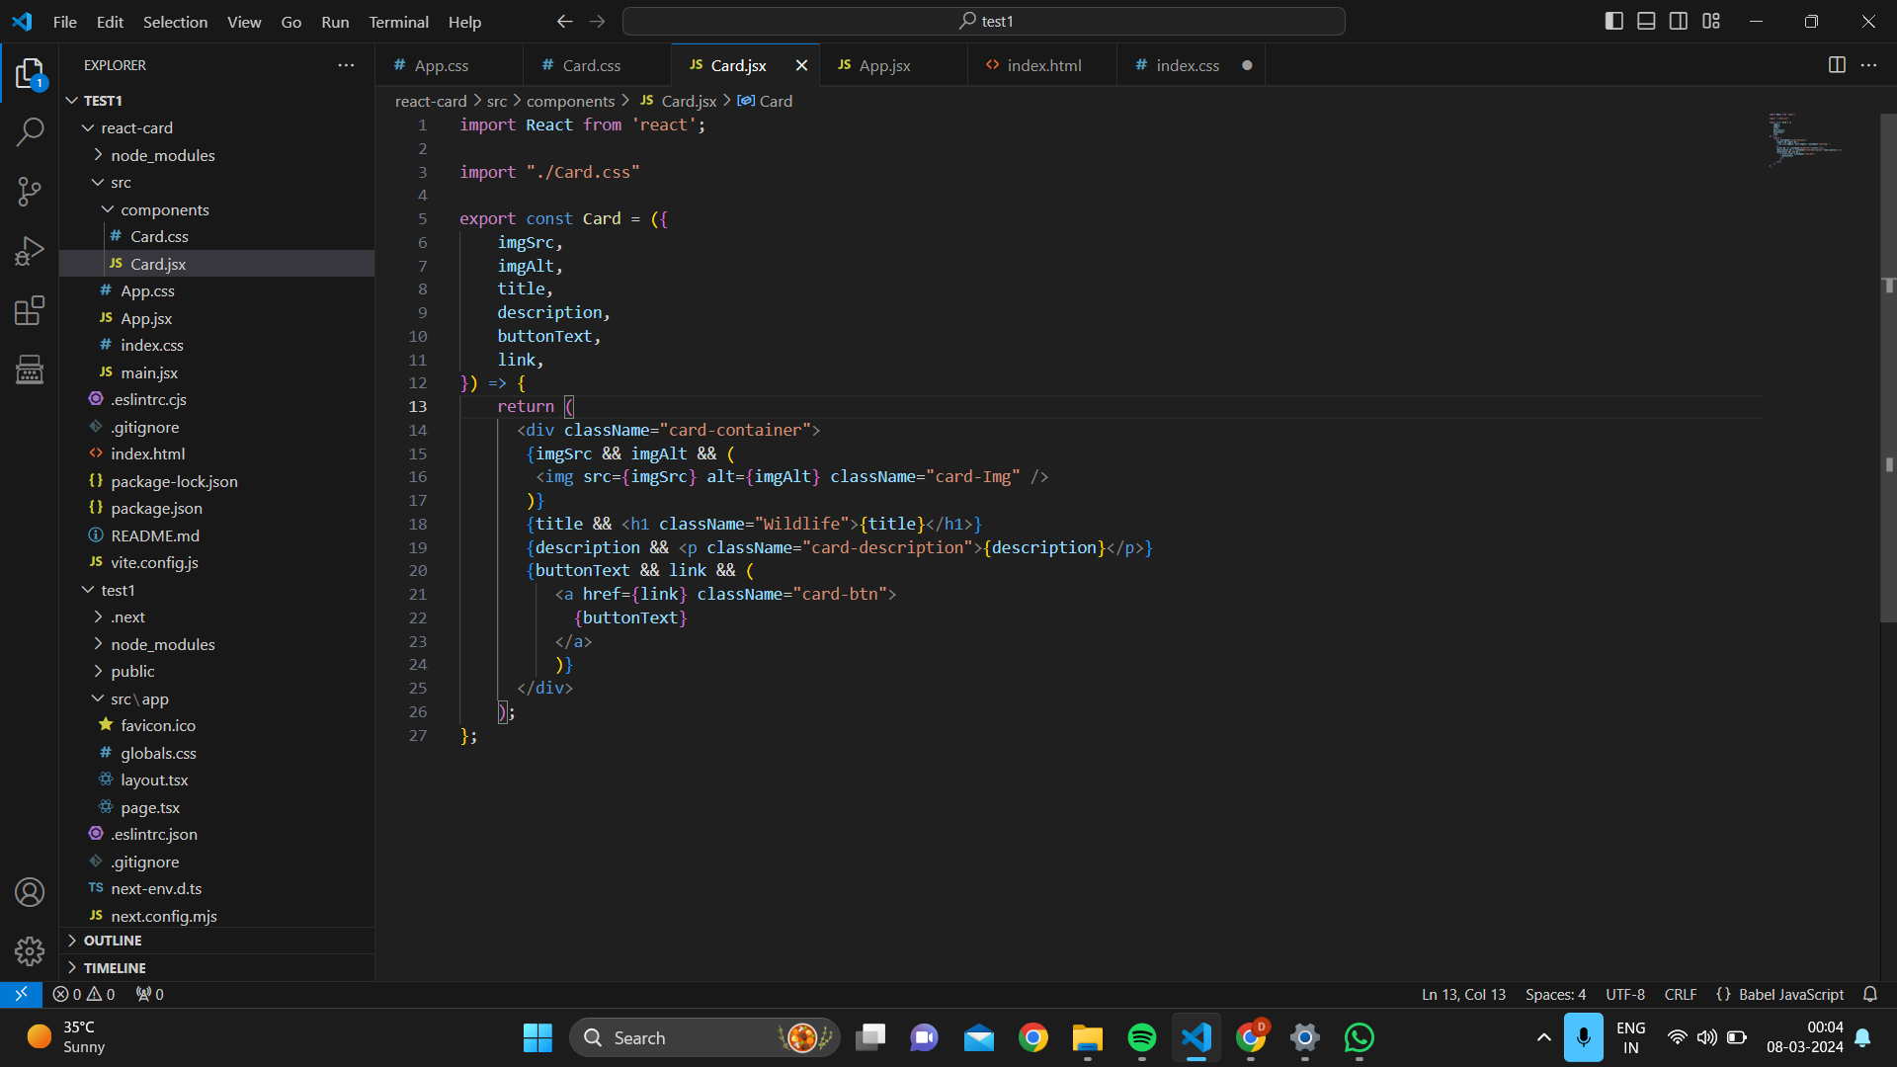

Card.css:

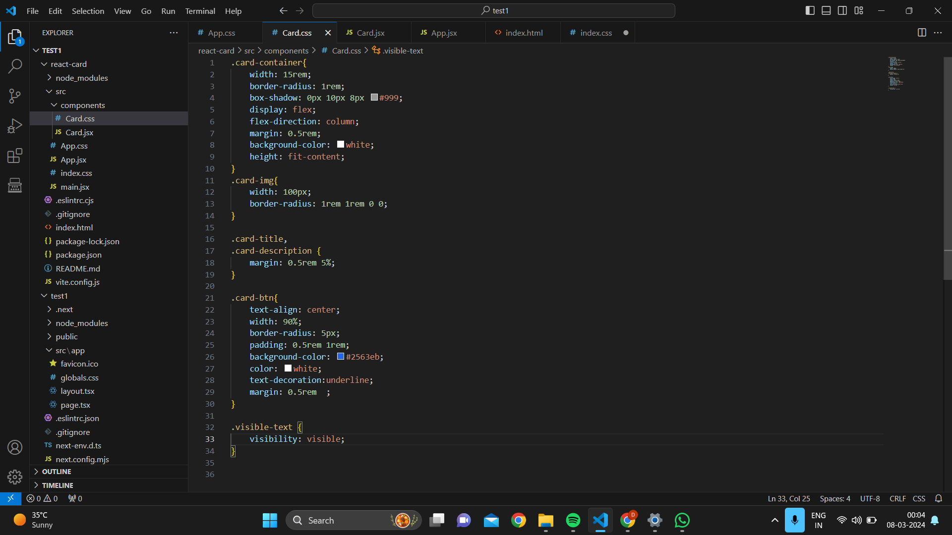

App.jsx:

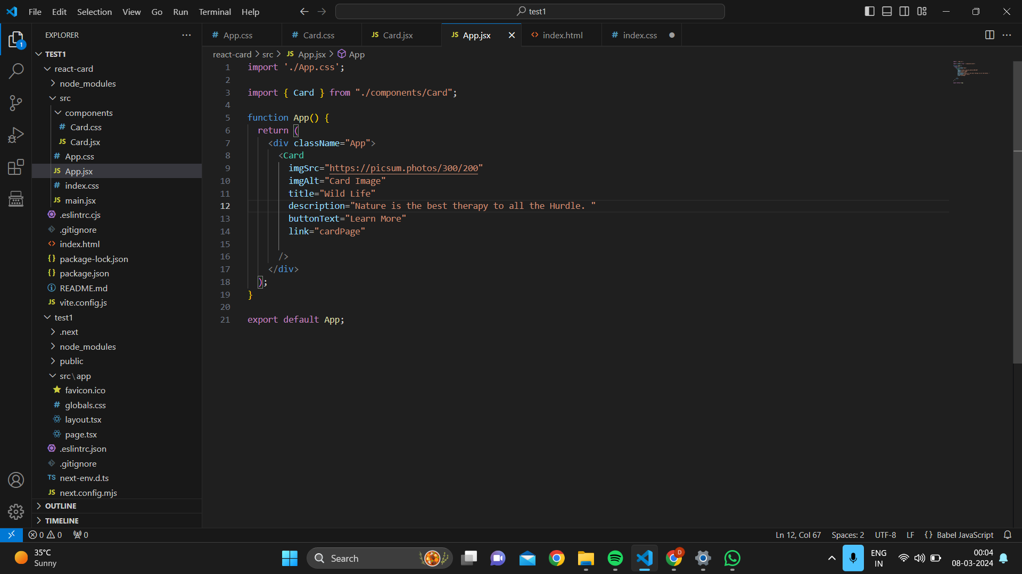

App.css:

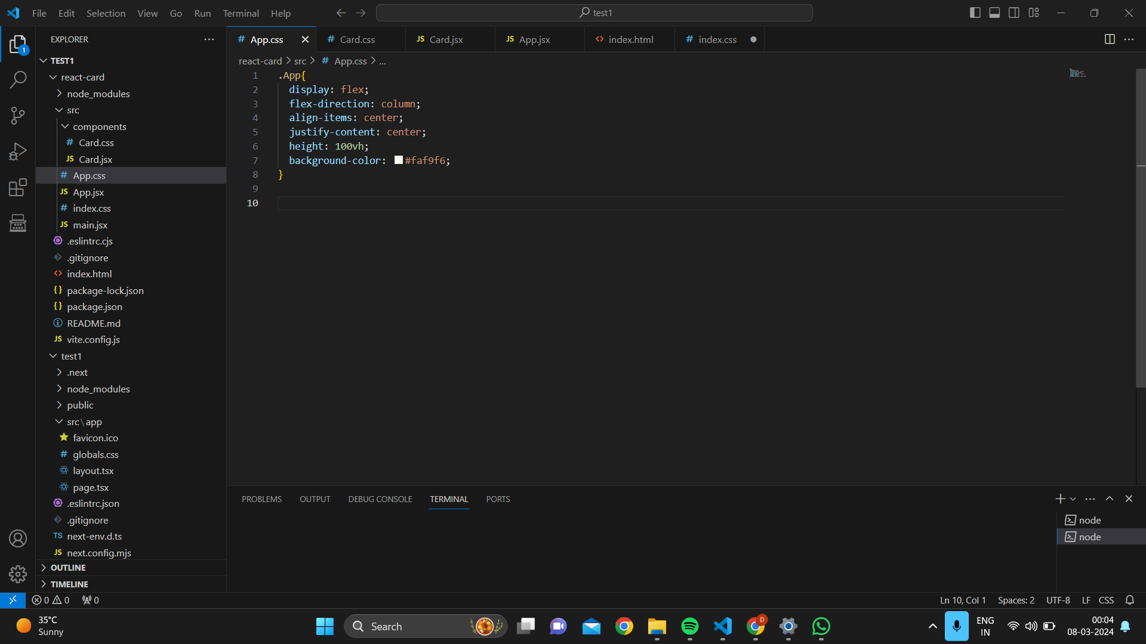

Output:

